**ABOUT US**

**Providing Information for a more Desired Humanitarian Action**

**Beacon Support For The Needy Initiative (BSN)** is a leading global humanitarian initiative that aims to strengthen evidence-based decision-making by Non-Governmental Organizations (NGOs), civil society organisations (CSOs) and decision-makers through regular and efficient data collection, management and timely information and in-depth analysis from contexts of disaster, crisis and displacement. The work of **BSN** directly feeds into aid response by providing accessible and precise information on the humanitarian situation of crisis-affected populations in which felt needs of the vulnerable women and children and excluded are addressed.

Created in 2022, **BSN** will conduct activities in support of inter-agency coordination mechanisms in the field to enable more efficient aid planning and response.

**MISSION**

To support **humanitarian actors to** efficiently respond to the need of crisis-affected populations and felt needs of the vulnerable people and excluded.

**VISSION**

**To provide support to** humanitarian actors by providing **evidence-based and** factual **information through efficient data collection, management and analysis in contexts of crisis.**

**OUR TEAM**

BSN’s teams consist of 61 data analysis, geographic information system, assessment, and field coordination experts, based across the 36 states and FCT Abuja we work in. Furthermore, our large-scale assessments are made possible by the contribution of over 800 short-term staff that join BSN on a yearly basis to support data collection and field implementation.

**WHAT WE DO**

EXPERTISE

**DATA COLLECTION & ANALYSIS**

**Inter-agency assessments**BSN conducts and facilitates field-based assessments in its 36 + FCT Abuja of operation. All assessments are a collaborative effort led by dedicated teams of data collectors, encoders and analysers.

**Remote sensing**BSN uses remote-sensing and satellite imagery analysis as complementary tools for rapid primary data collection, damage assessments and the mapping of the impact of disasters and crises.

**DATA DISSEMINATION**

**Our Data dissemination is done through Publications**

BSN teams analyse and disseminate information to aid actors in the form of tailor-made products such as reports, context profiles, situation overviews and factsheet.

**Maps**BSN produces maps that visualize information ranging from the scale of damage due to conflict to the location of critical infrastructure or displacement sites.

**Web-maps & online dashboards**  
BSN develops interactive web-maps and online dashboards to allow aid actors to access and utilise information in their programming. Open and transparent, the information can be used by actors to design an effective response.

**STRATEGIC FRAMEWORK**

MULTI-SECTORAL PLANNING

BSN conducts independent multi-sector and sectoral assessments that inform humanitarian decision-making. We also facilitate:

**MULTI-SECTOR ASSESSMENTS**

BSN also support multi-sectoral assessments support specific humanitarian milestones such as the Humanitarian Needs and Response Plans on Crisis-wide and inter-agency

**HUMANITARIAN SITUATION MONITORING**

Regular humanitarian situation monitoring provides multi-sectoral, granular and up-to-date information on the humanitarian needs of crisis affected populations, including in hard to reach areas.

**RAPID ASSESSMENTS**

Rapid assessments inform immediate decision-making and aid responses following sudden shifts in conditions, changes in dynamics and rapid developments in humanitarian situations.

**CLUSTER SUPPORT**

**BSN partners with the Clusters to support assessments, information management and planning. We serve as local hub for assessment on Global WASH and Shelter Clusters.**

**CASH**

**BSN supports humanitarian actors to plan and monitor the use of cash as a response modality.**

**Displacement and migration**

Displacement and migration are at unprecedented levels across the world. BSN informs policy-makers and response planning by providing information on:

**CAMP & HOST**

Assessments on needs and vulnerabilities of internally displaced people, refugees and migrants as well as host communities across camps, villages and cities impacted by displacement and migration.

**MOVEMENTS AND INTENTIONS**

Tracking movements and numbers of internally displaced people and returnees, while shedding light on movement and return intentions and vulnerabilities.

**MIXED MIGRATION**

Understanding push and pull factors, intentions and vulnerabilities of migrants in their countries of origin, along the migration routes and in their countries of destination.

**PUBLICATIONS**

BSN collects and analyses large quantities of primary and secondary data in contexts of crisis and disaster. BSN’s publications inform the decision-making and program development of hundreds of humanitarian actors and partners (clusters) working at field. Below is a selection of featured BSN publications. To access all BSN publications BROWSE BY THEMES

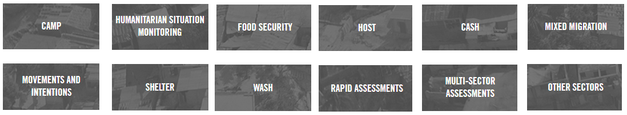

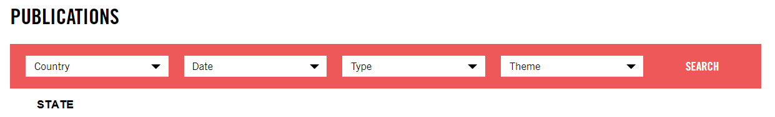

Publications will be inside the theme and here (plain) + you can choose them from the drop down.

**KEEP IN TOUCH**

Face book Twitter In

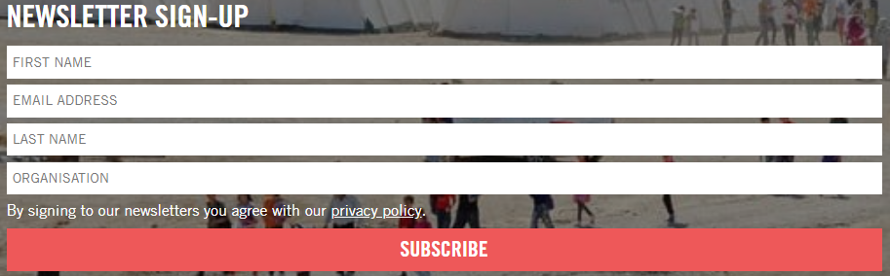

Footer



**Phone numbers and email**

**Phone:** 09099677750, 08067818238

**Email:** [bsn.ngo@gmail.com](mailto:bsn.ngo@gmail.com)

**WHERE WE WORK**

BSN works in places affected by crisis, disaster and displacement across the 36 States of Nigeria and FCT Abuja. In addition to ongoing support to humanitarian actors in protracted crisis, BSN deploys to rapid-onset crises ranging from natural disasters to sudden escalations of conflict. BSN’s work directly supports evidence-based decision-making from the very early stages of humanitarian planning and delivery.

**NIGERIA**

**COUNTRY OVERVIEW**



In north-east Nigeria, approximately 10 million people are affected by the humanitarian crisis, and since the start of the conflict in 2009, more than 71,000 people have been killed and 2.7 million displaced. Furthermore, banditry and farmer-herder violence has killed more than 21,000 people and displaced hundreds of thousands of people.

In spite of the turmoil and the critical humanitarian conditions faced by the conflict-affected populations, significant proportions of the displaced have begun to return to their areas of origin with over 6 million of people still in various camps across the country.

Humanitarian actors working in Nigeria continue to face significant information gaps lacking required granular and comprehensive evidence to efficiently inform their response planning. BSN will continues to provide up to date data to support actors working to address the humanitarian needs of vulnerable groups.

**PARTNER**

COLLABORATION

BSN promotes a collaborative approach and supports established inter-agency coordination mechanisms.

**NEWS**

LATEST RELEASES



LATEST NEWSLETTERS



Top of Form

Bottom of Form

**JOBS**



